**Chapter two**

**ANALYSIS OF THE EXISTING SYSTEM**

Jaclyn Mullen once said: “Sometimes we need to go backward before we can move forward.” Knowing deeply the existing system is vital to the conception of the new system. To have a clear image of the new system, we will describe the process of monitoring and evaluation of activities in organizations. For us to understand the existing system, we will try to explain some terms that will be used, the methodologies and the environment in which the system will be implemented.

**Specific terminology**

Before the analysis of the existing system it is better to have the same understanding of terms which will be used. So let explain some of those terms.

**A system**

A system is a combination of interacting elements organized to achieve one or more stated purposes (Bertalanffy, 1968).

According to (Alexander,2015) a system is a set of interacting or interdependent component parts forming a complex/intricate whole, every system is delineated by its spatial and temporal boundaries, surrounded and influenced by its environment, described by its structure and purpose and expressed in its functioning.

**Information System**

An information system (IS) is the study of complementary networks of hardware and software that people and organizations use to collect, filter, and process, create, and distribute data. Information systems are combinations of hardware, software, and telecommunications networks that people build and use to collect, create, and distribute useful data, typically in organizational settings (Terry, 2005).

**Management Information System**

Management Information System (MIS) is a computer-based system that provides managers with the tools to organize evaluate and efficiently manage departments within an organization.

In order to provide past, present and prediction information, a management information system can include software that helps in decision making, data resources such as databases, the hardware resources of a system, decision support systems, people management and project management applications and any computerized process that enables the department to run efficiently.

**Currency**

Currency is a system of money in general use in a particular country or the fact or quality of being generally accepted or in use.

**Forex bureau**

Forex Bureau is business of which primary purpose is the selling and buying of a foreign currency in exchange of the the local currency.

**Service**

Service is something that the public needs, such as transport, communications. In our case service will be forex bureau currency exchange of our customer’s public.

**Report**

The act or an instance of asking for something, the report can be in terms of documents or support etc.

**Description of the national bank of Rwanda forex bureau exchange**

**History**

The primary activity of Forex Bureau business is the buying and selling foreign currencies. It is in this context that no individual or a company is authorized to transact in foreign currencies unless it is licensed by National Bank of Rwanda. It is through this mandate that the National Bank of Rwanda is in charge of regulating and supervising Forex Bureau to ensure that their complying with laws and regulatory requirements.

**Vision**

The Vision of the Bank is to become a World-Class Central Bank

**Mission**   
The mission of the Bank is to ensure price stability and a sound financial system

**Figure 1**: **Organization structure**

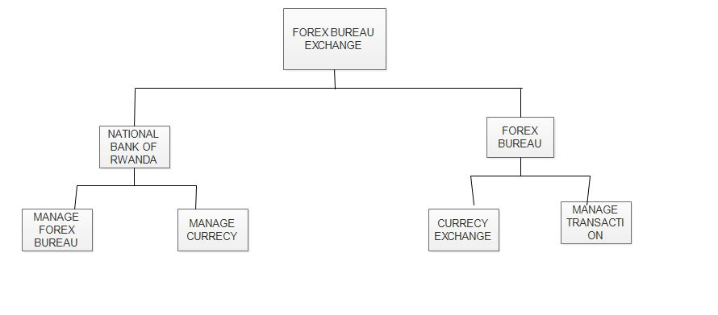

As we described in the first chapter, this existing system was found to be completely manual, where BNR want the report or information on currency because the reporting of forex bureau is manual and other system is not update on time. When NATIONAL BANK OF RWANDA want report of forex bureau waiting for forex bureau to send it and when the new currency come forex bureau went to BNR to be update which is not good. This cause a big problem, BNR take a long time for correct reporting where there is forex bureau are still having problem of reporting because lack of system which is manual.

So, we develop a computerized system called “FOREX BUREAU REPORTING SYSTEM “ which will be solving that problem by using web application where the national bank of Rwanda and forex bureau exchange at all will be use it and minimizing their daily to day activities.

### **Problems of the existing system**

As our case study in “NATIONAL BANK OF RWANDA” they are using manual system to reporting and managing forex bureau they don’t have same application help them to get report at a time.

* This may cause many obstacles for both sides (BNR and Forex bureau) like lack of information which is not good in monitor currency
* Manual systems put pressure to people who correct those all detail information of their work on time. This may take a long time to correct all corrected report information which is not perfect depending on the level of our technology.
* This may discourage some activity of exchange and monitoring currency in NBR which National Bank of Rwanda is needed to control.
* It takes time to know the total number of customer’s requests for currency exchange
* It takes time to evaluate services based on customer’s requests because those requests are not all recorded and saved requests are in ambiguity.

**Analysis of the existing system**

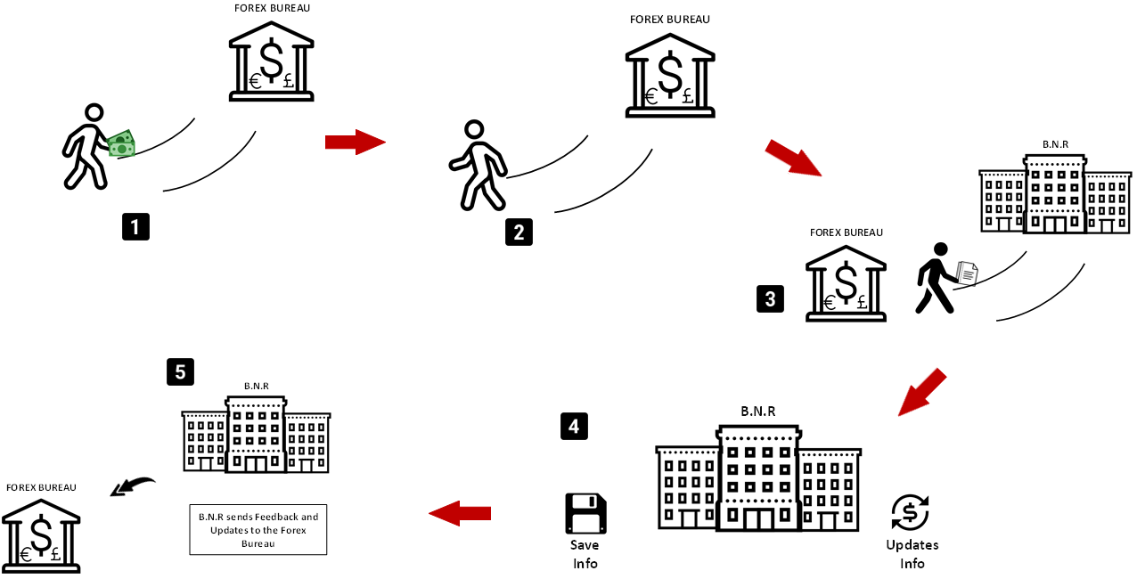

**Collection technique**

In data collection technique one or many technique may be used.

The following data collection techniques where used to understand the existing system:

**Observation:** Observation is a way of gathering data by watching behavior, events, or noting physical characteristics in their natural setting. The observation will be indispensable to collect data on the actual work reality. We have used this one to observe what happens in New Artel.

**Interview**: It is defined as a systematic conversation between an investigator (interviewer) and an informant (interviewee), initiated for obtaining information relevant to a specific study. Different staff employees of forex Bureau Company’s were interviewed in order to collect data.

**Documentation**: The documentation is oriented towards a systematic excavation of all writings linked with the research domain and it helped us to collect useful documents, archive reports related to forex bureau.

**New System Overview**

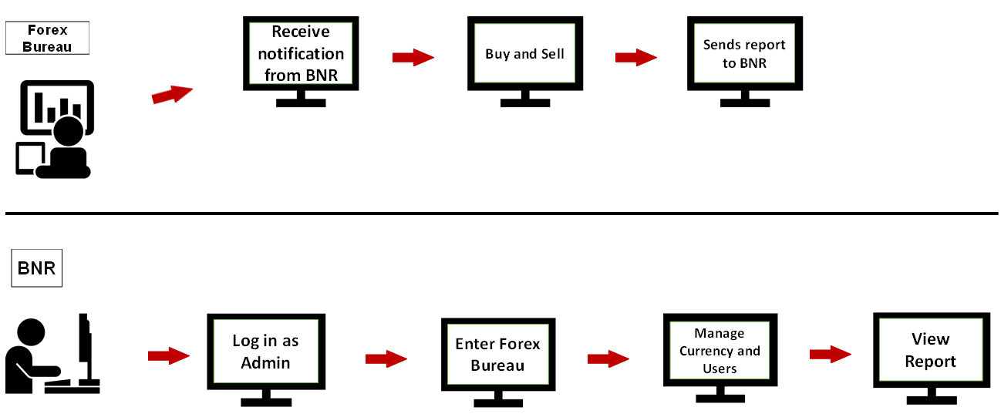

**Proposal solution**

This new system will be named the online forex bureau management System, this will help BNR to get report of any forex bureau .it will also help BNR to control and to get service compare with existing system such as:

* The new system will allow BNR administrator to update a new currency, to view Report and to put a new range of exchange rate.
* The new system also will help all forex bureaus to make report and to be updated about update currency exchange on time.
* The new system will allow new forex bureau exchange and national bank of Rwanda to know the total number of all customers’ requests for exchange.
* Evaluation of services will be allowed
* The system also will provide document reports of all requests.